Parents/Guardians,

As part of entering into first grade, I ask that you complete each reading assignment as well as the math assignment for the summer. The reading assignment includes a reading log and a reading project as well as Kindergarten review work. For math, I ask that you use either a computer or an iPad to access the assignment and complete each part.

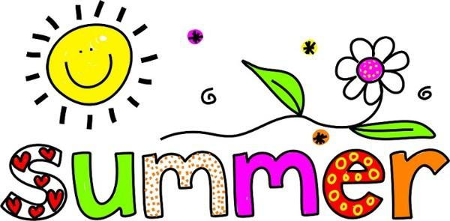

-------------------------------------------------------------------------------------------

First Grade Summer Work

Dear Incoming First Grade
Dear Rising First Grader,
Congratulations on finishing Kindergarten and welcome to first grade! I am so excited to have you as part of our class next year! In order to be fully prepared for Language Arts, I ask that you…
- Review all letters of the alphabet, both lower and upper case
- Review all letter sounds and review words that start with each letter
- Review all Kindergarten sight words as well as begin to learn the First Grade words (list attached)
- Choose 1 of the 4 book report options to be turned in on the first day of school (options attached)
- Complete the Reading Log (attached)
- Consider finding out your child’s “Reading Personality” by completing the attached survey made by A Book and a Hug (abookandahug.com/reader-assessment). Use this survey when choosing books to put on the reading log! The survey is found on that website with instructions on how to access the assessment! *THIS IS OPTIONAL*
In addition to Language Arts work, I ask that you review and sharpen up your child’s Math skills. These skills include…
- Basic facts to 10
- Word problem with sums and differences to 10
- Number sense
- Counting to 100
- Skip counting by 10
- Identifying shapes both 2D and 3D
In order to do this accurately and to allow for us to ensure that these facts are being practiced, I ask that you log on to prodigygame.com. Select the “Play Prodigy” button in the upper right hand portion of your browser window. Enter in your child’s username and password (attached). Select the “login” button and the game will automatically begin to load. With each activity completed, an assessment will be sent to us! If you want to quit in the middle of a game, just select the gears at the bottom of the screen and log out! Our class code is 467141.
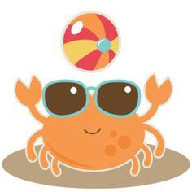
Again, congratulations on moving up to first grade and we can’t wait to see you all come August!

Book Report Choices
*CHOOSE ONE*

1. Characters Come to Life
- Create a portrait of one of the characters in the book.
- On the back, provide a written portion telling who the character is, words to describe the character, and one sentence about something the character did in the story that made him or her stand out to you. Please do not forget to include the title and author of the book, also!
- Materials needed: construction or computer paper, markers, crayons or colored pencils, and a pencil
2. Book Jacket
- Think of a new title for the book! Create a new book cover for the story with your new title and an illustration to go with it.
- On the back, please include one sentence telling me why you changed the title to what it is now.
- Materials needed: construction or computer paper, markers, crayons or colored pencils, and a pencil
3. Make a Pizza Book Report
- Slice 1: Write the title and the author of the book and include a drawing of the cover of the book.
- Slice 2: List all of the characters found in the book then draw a picture of one of those characters.
- Slice 3: Draw a picture of one setting (where the story takes place) in the book.
- Slice 4: Provide a summary of the story (1 to 2 sentences about the book)
- Materials Needed: Using a large, circle piece of construction paper or poster board, draw a circle with 4 slices, crayons or colored pencils or markers
4. For Non-Fiction Books make a 3 – 2 – 1 Chart
- Name 3 interesting facts that you learned
- Name 2 new words that you learned and what they mean
- Name 1 question you still have about the topic
- Materials Needed: Materials needed: construction or computer paper, markers, crayons or colored pencils, and a pencil

Kindergarten Sight Words

I | am | little | a | to | have | is
we | like | my | he | for | me | with
she | see | look | they | you | of | are
that | do | one | two | three | four | five
here | go | from | yellow | blue | green | what
said | was | where | come

First Grade Sight Words

in | on | way | and | take | up | get
help | use | eat | her | this | too | saw
small | tree | your | home | into | many | them
good | want | no | put | be | out | who
work | down | now | there | find | grow | also

