St. Casimir School: Catholic Schools Week

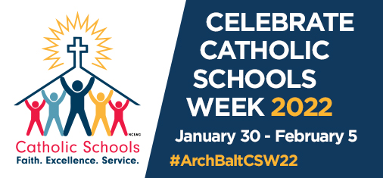

Date | What’s Happening
Sunday, January 30th | Kick-Off to Catholic Schools Week  Catholic Schools Week Mass: 10:00 AM  St. Casimir Catholic Church  Student + Faculty to participate
Monday, January 31st | Celebrate Families  Book Fair  https://www.scholastic.com/bf/stcasimir1  Grandparent’s Day  Special treats for our families at drop-off
Tuesday, February 1st | Celebrate the USA  Wear your Red, White and Blue  Celebrate Veterans
Wednesday, February 2nd | Celebrate Students  Ice Cream Sundaes at lunch or snack time!  Virtual assemblies  Students dress down day
Thursday, February 3rd | Celebrate Community  Dance, Shake and Donate (Middle School)
Friday, February 4th | Celebrate Faculty and Staff  Noon Dismissal

