SUMMER READING 2023
FOR STUDENTS ENTERING GRADE FIVE
Students entering grade five will be expected to read THREE books this summer. The first should be chosen from the list below and will be the subject of their Book for Sale project. The second can be any novel of their choosing. The third should be a nonfiction selection of their choosing.
ASSIGNMENTS
FICTION NOVELS:
Students should complete the BOOK FOR SALE PROJECT report for one of the novels below: NOVELS (Choose One)
Matilda, by Roald Dahl
The Mostly True Adventures of Homer P. Figg, by Rodman Philbrick
Coraline, by Neil Gaiman
Mudshark, by Gary Paulsen
The War with Grampa, Robert Kimmel Smith
The One and Only Ivan, by Katherine Applegate
Cricket in Times Square, by George Selden
Where the Mountain Meets the Moon, by Grace Lin
Chasing Vermeer, by Blue Balliett
RECORDING SHEET: You should also include a book recording sheet to show that you have completed the required reading.
IMPORTANT: These assignments will be the first grades you will receive in fifth grade for language arts:
Book for Sale Project: 24 points
Reading Recording Sheet: 10 points
“BOOK FOR SALE”
Fifth graders are going to create a product for “sale” in a store
based on their novel.
FIRST: Find a container that you could use. ANY container that
you can decorate is fine. Shoe boxes, oatmeal containers, amazon
boxes, etc. are all appropriate. Something recyclable is best!
THEN: DECORATE your box to represent the book that you read. The title and author should be visible and easy to read from a store shelf. An “ingredients list” should include the setting along with some of the main and minor characters. Also, please include a SHORT summary of the main idea of the book. The text and graphics on the box should entice a customer to purchase the “book.”
NEXT: Find 8 - 10 items to include in your box that are important to the story with a 1-2 sentence explanation as to WHAT they are and WHY they are important. These items can be actual physical items, drawings, pictures from the internet or a magazine.
FINALLY: Be prepared to “sell” your product by presenting it to the class in the fall.
HAVE FUN! This project is a 24 points assignment, and will serve as their first Reading Grade for the first trimester.
Rubric:
OUTSIDE THE BOX INSIDE THE BOX OVERALL Decoration (2 pts) 8 items with Accuracy (4 pts) Title and Author (2 pts) explanations (8 pts) Effort (2 pts) Ingredients (3 pts)
Summary (3 pts.)
5th GRADE SUMMER BOOK RECORDING SHEET (10 points):
This summer I read:
Book #1 ________________________________ by ________________________ My favorite thing about this book was
Book #2 _______________________________by _________________________ My favorite thing about this book was
NON FICTION BOOK _______________________________ by __________________ Two interesting facts from this book:
Student signature _____________________ Parent Signature ____________________

Summer Math
for Incoming Fifth Graders

This summer, students will earn their first two grades for math as fifth graders.

PART I: All incoming students should complete the following in their IXL Account. Students should attain 80% mastery in each recommended section. These will appear as recommended skills in their IXL program, and also appear here as a checklist. Use this checklist to make sure you are on track for your summer work. Students who achieve 80% mastery will receive 100% for the assignment.

The following required sections can be found in RECOMMENDED SKILLS
______Prime and Composite up to 20
______Round a number to any place: up to hundred thousands
______Add two numbers up to five digits: word problems
______Subtraction: fill in the missing digits
______Multiply 1-digit numbers by teen numbers using grids
______Find two numbers based on sum and difference
______Distributive property: find the missing factor
______Divide 2-digit numbers by 1-digit numbers: interpret remainders
______identify equivalent fractions
______Area and perimeter: word problems
______Acute, right, obtuse, and straight angles
______Add and subtract fractions with like denominators
______Value of a digit
______Section of your choice ___________________________________
______Section of your choice ___________________________________

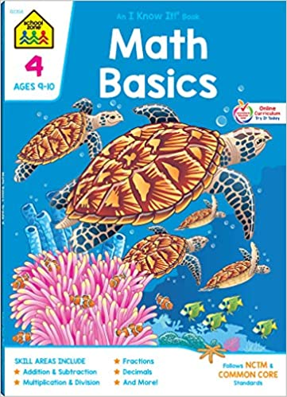
Part I ALTERNATE Assignment: if you do not wish to work on IXL. Please purchase this leveled math review book available in major retailers and on Amazon.com for $3.99. Students should complete every third page (multiples of 3 (pg, 3, pg 6, pg. 9, pg 12, pg. 15, 18, etc.) This should be handed in the first week of school.

ISBN #: 978-0887431401

PART II: (10 point assignment):

Students should also choose six weeks to practice multiplication and division facts. (15 min. per day, 4 days per week). Math fact practice logs are attached and need to be handed in when school resumes in the fall for full credit on this assignment. Fact practice can include a parent quizzing a child with flash cards, an online program such as IXL.com, multiplication.com, hooda math or mathisfun.com or any other method that allows a student to review math facts. Please have a parent or caregiver sign each practice log. Practice logs may be split up over weeks as long as the student has six weeks worth of practice accounted for.

If your student uses IXL.com for facts practice, please be sure to log into your account

