March 11, 2020

Dear Saint Casimir School community,

Saint Casimir and the Archdiocese continue to collaborate to ensure proper and timely management of the fluid situation we are dealing with surrounding coronavirus (COVID-19) in Maryland. We are closely monitoring the reports surrounding coronavirus to make informed decisions to keep our students, faculty and staff safe.

After much consideration and in an effort to protect the well-being of our school community, all field trips and activities outside of Maryland are cancelled until further notice. All previously scheduled in-state activities will be evaluated with the students and families safety and health being the driving factor in the decision whether we proceed with the activity.

As we communicated during the height of the flu season, we continue to be vigilant in keeping our school facility clean and safe. We encourage all to continue to practice good hygiene by washing hands frequently.
If your child is sick, they should be kept home from school and please advise the school of their illness or if they have been exposed to the coronavirus.

In addition, our faculty is working with the Archdiocese Department of Catholic Schools to prepare learning resources for families to engage their child in educational opportunities at home if our school were to be closed for an extended period of time due to the virus.

Finally, as spring break approaches, we encourage you to take appropriate precautions as recommended by the CDC and U.S. Department of State should you decide to travel. Please also visit the Maryland Department of Health website for more information on health precautions related to travel. At present, if you or a member of your family travel to a high-risk country, we request you follow the recommended guidelines for self-quarantine https://www.cdc.gov/coronavirus/2019-ncov/travelers/after-travel-precautions.html

The health and safety of the Saint Casimir community is our top priority. We will continue to provide you updates and, in the interim, feel free in all cases to contact us should you have any concerns.

Yours in Christ,

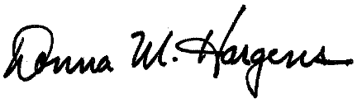
Principal Donna M. Hargens, Ed.D.
Noreen Heffner Superintendent

