SUMMER READING FOR STUDENTS ENTERING GRADE FIVE

Students entering grade five will be required to read TWO books this summer. The first is a novel that should be chosen from the list below. The second should be a nonfiction selection of their choosing. It is highly recommended that your child spend 15 min. a day reading throughout the summer.

REQUIRED FICTION NOVELS:
Students should choose to read one of the titles listed below. Each student should create a Book-in-a-Box project based on the required reading book to present in the fall. Directions and rubric are attached.

NOVELS (Choose One)
Matilda, by Roald Dahl
The Mostly True Adventures of Homer P. Figg, by Rodman Philbrick
Coraline, by Neil Gaiman
Mudshark, by Gary Paulsen
The War with Grampa, Robert Kimmel Smith
The One and Only Ivan, by Katherine Applegate
Cricket in Times Square, by George Selden
Where the Mountain Meets the Moon, by Grace Lin
Escape from Mr. Lemoncello’s Library, by Chris Grabenstein
Chasing Vermeer, by Blue Balliett

NONFICTION BOOK:
Students must choose a nonfiction book on a high interest topic and complete the nonfiction book report (attached).

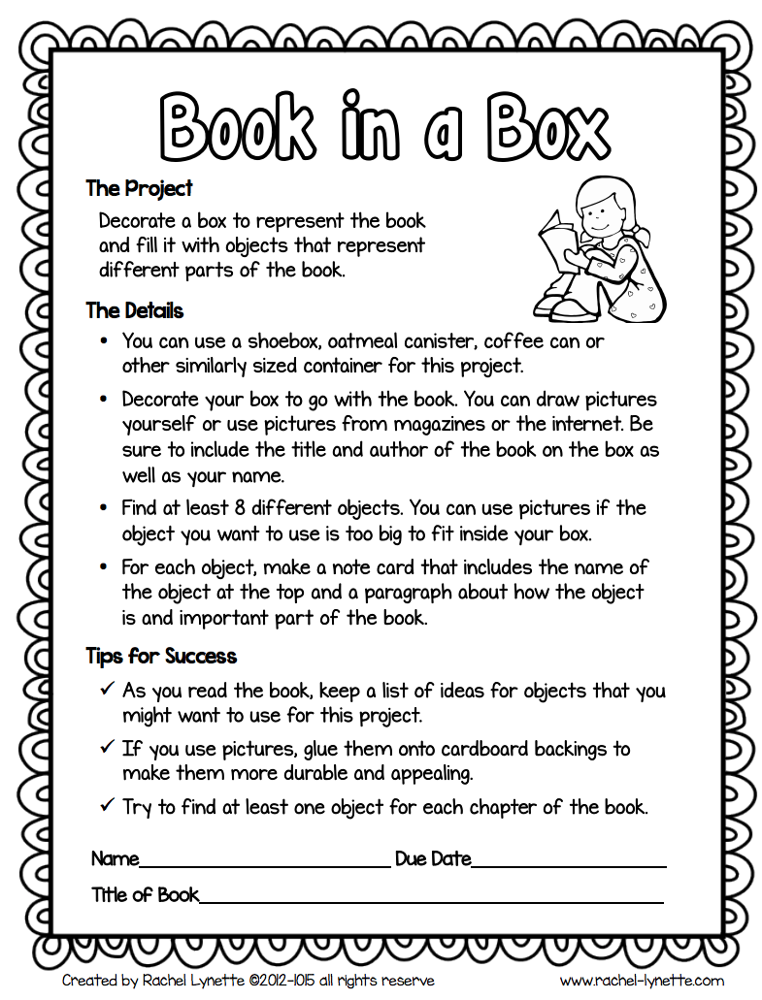
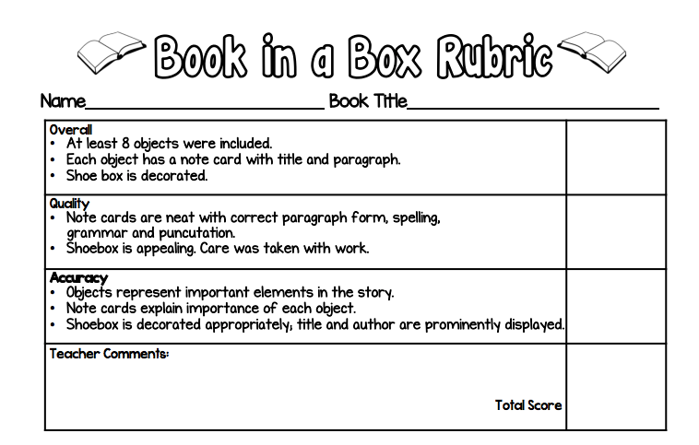
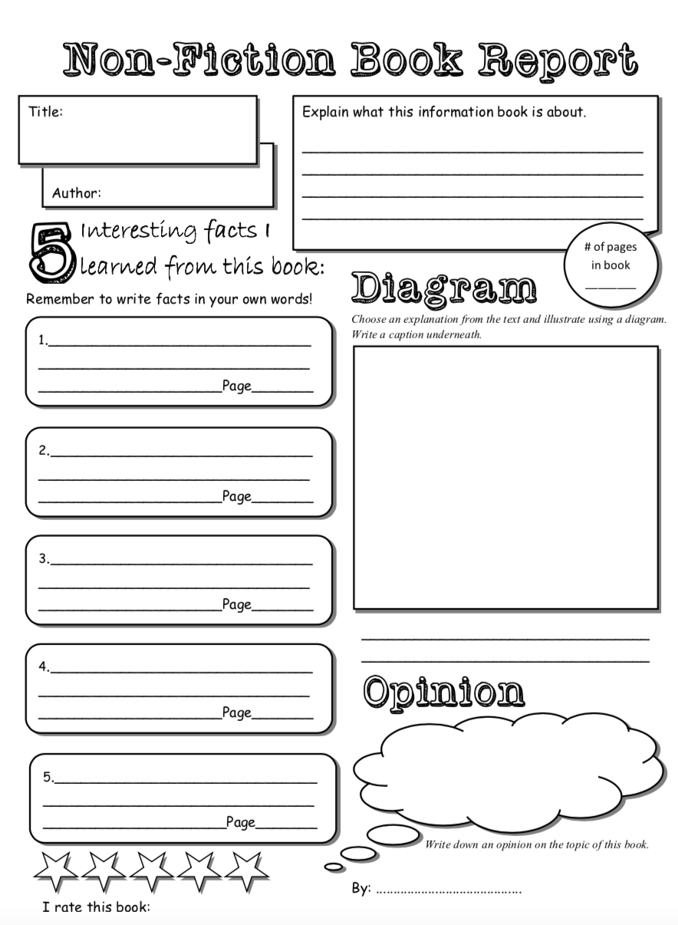
Summer Math
for Incoming Sixth Graders

This summer, students will earn their first two grades for math as sixth graders. Summer math will include two activities: a leveled math review and multiplication/ division fact practice.

Math Leveled Practice:

All incoming fifth graders will be required to complete 20 pages of any fifth grade math book. Some recommended titles are:

- Summer Bridge Activities®, Grades 4 – 5 ($12.02 on Amazon)
ISBN: 9781594417306

Summer Express Between Fourth and Fifth Grade ($9.99 on Amazon)
ISBN: 978-0545226943

Spectrum Math Workbook, Grade 4 ($7.78 on Amazon)
ISBN: 978-1483808727

If you child has already completed fifth grade math last year, any of these titles would be appropriate over the summer for the next grade (6th -7th ) grade).

Multiplication/Division Practice:

Students should also chose six weeks to practice multiplication and division facts. (15 min. per day, 4 days per week). Fact practice can include a parent quizzing a child, an online program such as multiplication.com, hooda math or mathisfun.com or any other method that allows a student to review math facts.
Please return Math practice log first week of school.




