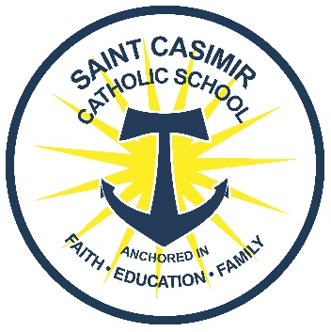
January 8, 2020
Dear Parents,
Our new student enrollment will open during Catholic School’s week. We already have many applications in the pipeline for next year. We need your assistance to help us determine how many new students we can accept for the 2020-2021 school year.
Please fill out the bottom portion of this form and return it to school before January 20th. All forms MUST be returned.
The re-enrollment process for current students will begin the second week in February. If you have a child that is not currently enrolled please use this link https://www.stcasimirschool.us/admissions/how-to-apply and fill out an application ASAP to hold their spot. Thank you!
If you have any questions please email Ms. Kath at admissions@stcasimirschool.us.

Intent to Return Form
Student’s Name ______________________________ CURRENT Grade ____________
____ Yes, we plan to enroll our child for the 2020-2021 school year.
____ No, we do not plan to enroll our child for the 2020-2021 school year.
____ We are unsure at this time.
If you have another child that will be a new student to St. Casimir in the 2020-2021 school year please indicate that here: Name:_____________________________ Grade:_______ DOB ____

