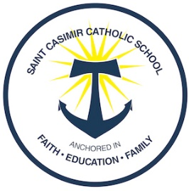 DELICIOUS HOMEMADE LENTEN FOODS

Menu and Pricing
- Coddies: Fried $3.00, Unfried $2.75
- Crab Cakes: Fried $8.00, Unfried $7.75
- Macoroni or Potato Salad: $3.00
We are pleased to be able to keep our prices the same but we will not be able to offer crackers or mustard this year.
To place an order:
Email: lentenfoods@gmail.com
Call: 443-414-6784, 443-224-0906
School fax: Before 2:00 pm, 410-342-5715
* ALL ORDERS must be received by 2pm on the Order Date* Please designate your pick-up time.

Place Order by 2:00 on This Day | For Pick-up from 8-3 on This Day
Monday, 2/15/2021 | Ash Wednesday, 2/17/2021
Tuesday, 3/2/2021 | Friday , 3/5/2021
Tuesday, 3/16/2021 | Friday 3/19/2021

Pick-up Information:
Orders are to be picked up between the hours of 8:00 AM and 3:00 PM at the Kolbe Center, 1st floor (directly behind St. Casimir Church). For curbside pick-up please call or text 443-414-6784 upon arrival!
We deeply thank you for your support of our students!
St. Casimir Home & School Association

