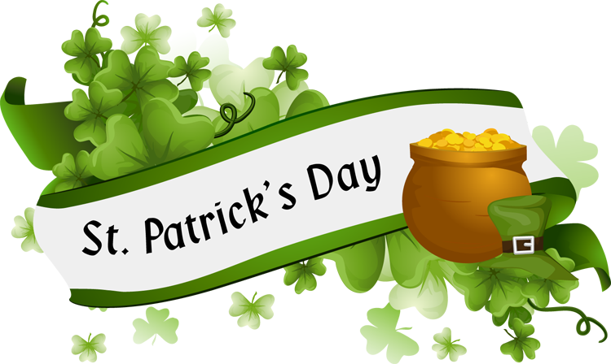

Good morning, Today is Tuesday, March 17th. Happy Saint Patrick’s Day.

A special Saint Patrick’s Day greeting from Mrs. White!
https://www.dropbox.com/s/abvxb6rnqdn0wye/6W8A2035.MOV?dl=0outu.be
Check out these facts about Saint Patrick’s Day from National Geographic for Kids. https://kids.nationalgeographic.com/explore/celebrations/st-patricks-day/
Here is another website for Saint Patrick’s Day activities:
https://coolprogeny.com/2020/03/cool-fun-at-home-leprechaun-adventures/

Don’t forget your morning prayers and end of the day prayers.
We are so proud of you for working so hard at home. Keep up the good work!

Maybe today or during the week you may want to make cards for those in nursing homes and hospitals who can’t have visitor like Mrs. Tina’s husband, Mrs. Dudley’s husband and Ms. Lawson’s niece Abby. You can mail them or drop them off at school and we will get then to them.
Here is the website for mini Mystery Doug science videos by grades free at home. https://mysteryscience.com/school-closure-planning
Thanks to Mrs. Dudley for sharing this list of educational websites that are free during the closures.
https://kidsactivitiesblog.com/135609/list-of-education-companies-offering-free-subscriptions/?fbclid=IwAR0tBXLc7Xn0NyzkUY-W2Y1EE2-qXb8bc4XOb0ZjXia1HQ1w21vvjMFBUp4

Joke of the Day:
Q: What kind of spells do leprechaun witches cast?
A: Lucky Charms!
Q: What type of bow can’t a leprechaun tie?
A: A rainbow.
Happy Birthday
This Photo by Unknown Author is licensed under CC BY-NC-ND
- Jake Rusnak- Grade 8
- Max Yacumis- grade 1
The birthday box is ready for you when we return to school
Message and resources from the guidance counselor, Mrs. Crown is attached as a separate email.
Keep the jokes and pictures coming! Saint Patrick’s Day fun pictures welcome also. Email to school@stcasimirschool.us

