This Photo by Unknown Author is licensed under CC BY-ND

Good morning, Today is Thursday, March 19th. Not only is it the first day of Spring but it is also Incredible Kids Day. I hope you all have a great Incredible Kid Day!
In your morning prayers please continue to pray for Mr. Tim Micklos (Mrs. Tina’s husband and Abby (Ms. Lawson’s niece.) Please e-mail us if you have any intentions you would like us to remember in our prayers.
Our teacher message for the day comes from Ms. Wright showing us how she raises bees for honey. https://youtu.be/Ilpx2zbuaFg
Happy birthday today to Ms. Lawson!
School is open today from 9-3 if students need to pick up any books etc.
Fifth graders, I loved watching your Saint Patrick’s Day flip grids and meeting some of you pets.
Pre-K 4, you did a wonderful job with your leprechaun traps.

Your teachers all had a video chat yesterday and we all miss you. We will be meeting today in small groups to see what is working, what needs some work and what fun activities we can come up with for next week.

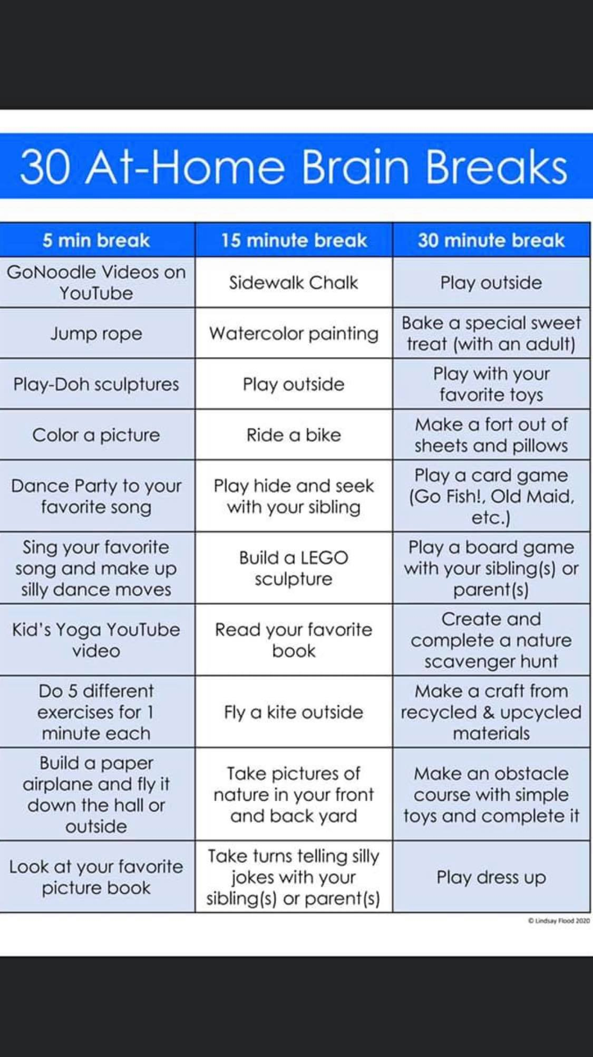

Here is a great list of activities to do with your children while working at home. So many of these activities are beneficial for physical, social, and cognitive development!
We are in constant communication with the state and the Archdiocese. As of next Friday, considering we did not use many of our snow days and todays professional day (that does not count as an instructional day) we are short 2 of the required instructional days. This will be reevaluated when we get to next week and more decisions are made about return to school.
After Care: Parents who are billed hourly will only be billed for the hours they used. Those who pay by the month or year will receive an email from Ms. Tina on Friday.
North Bay money will be refunded as soon as we receive it.
Please email Tina is you have any financial questions.

Joke of the Day:
Q: Which crime fighter likes spring the most?
A: Robin

