May 2, 2022
Newsletter

To come home:
- Field Day form
- Progress reports for students in K-8 who may need assistance to improve grades before the end of the year.
- Directions to Merritt Park

Field day: Each class is asked to wear a different color t -shirt or shirt on Field Day.
The colors for this year are:

Pre-k 3 Ms. Wright: red
Pre-k 3 Ms. Nicole: light blue
Mrs. E.: navy
Mrs. Morrison: lime green
K Mrs. Mel: royal blue
K Ms. Lohr: yellow
1 Mrs. Shortall: light green
1Ms. Grauel : dark green
2Ms. Spence::purple
3Mrs. White: Pink
4Mrs. Turcea: Yellow
5Mrs. Dudley: white
6Mr. Freburger: orange
7 Mr. Quinn: light blue
8 Mrs. Mathews :purple

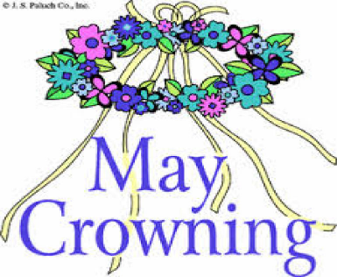May crowning: Thanks to our 7th and 8th Graders and first communicants for participating in the May court to Crown the blessed Mother on Sunday.
Savannah Wellman, Kaila Carter. Nate Aisquith, Daniel Girolami, Anthony Girolami, Willem Bartomioli , Ricardo Mejia and our first communicants.

May 13th: School Play
May 18th: Retreat Grade 8
Marshy Point - Grade 2
May 20th: Field Day

5/1/ Makenna Cary
5/2/ Beau Cannon
5/4/ Jenna Hasselberger
5/4/ Paige Purtell
5/7/John Hirsch
5/10/ Wyatt Aisquith
5/13/ Eason Gaba
5/14/ Vivienne Higley
5/14/ Addison Stoner
5/16/ Reece Schindler
5/20/ Luna Brockmeyer
5/20/ Blythe Washo
5/21 Mr. Josh
5/25/ A.J. McKown
5/26/ Teddy Saha
5/26/ Chace Schindler
5/26 Ms. Nadia
5/29/ Emma Mulligan
5/31/ Irina Lalicki
5/31/ Nicholas Purtell
5/31 Mrs. Lisa

