Dear St. Casimir School Community

First and foremost, please know that you are missed and remember that You Matter, You are Important and You Belong!!!

During this time of Distance Learning I am available to provide School Counseling Services remotely. Please email me to schedule a time and I will follow-up with you to schedule an appointment via Google Meet. I will also be in contact with administration and teachers regarding students who are in need of my support and I will reach out via email to check-in.

Please note that while I will make every effort to ensure confidentiality, please be aware that it cannot be guaranteed given the nature of virtual/phone communication and the presence of family members in the home. I will continue to follow protocol that if a student indicates a risk of harm to herself or someone else, I must share this information with the appropriate parties.

While I am available to support students, those in need of in-depth mental health counseling and services should seek treatment from licensed mental health providers in the community, many of whom are also offering virtual therapy through telehealth platforms. If you are seeking a referral to a local mental health provider, we are happy to work with you in facilitating that connection. In case of a mental health emergency during a time in which the counselors cannot be reached, please call 911 or see the list of crisis resources below.

Mental Health Crisis Hotlines:
- Baltimore County: 410-931-2214
- Baltimore City: 410-433-5175
- Howard County: 410-531-6677
- Harford County: 1-800-639-8783
- Carroll County: 410-952-9552
- Suicide Prevention Hotline: 1-800-273-TALK (8255)
- SAMHSA's National Helpline: 1-800-662-HELP (4357)
I have also attached two resources and I am working on creating a resource page:
In addition I highly recommend that parents/guardians:
Limit Screen Time- The American Academy of Pediatrics Recommends the following:
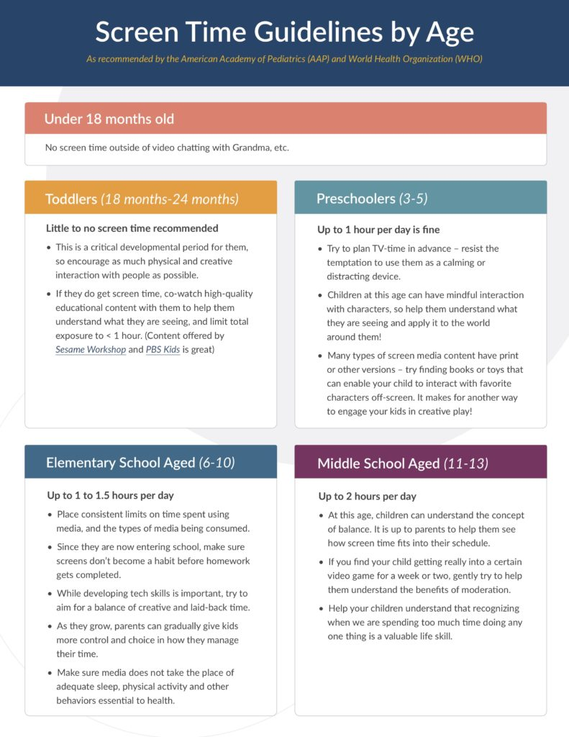
https://www.aap.org/en-us/about-the-aap/aap-press-room/news-features-and-safety-tips/Pages/Children-and-Media-Tips.aspx
Increase family time with games, cooking, dancing, listening to music and getting outside. Here is a list of parks in Baltimore City and County that you can access:
https://bcrp.baltimorecity.gov/parks
https://www.baltimorecountymd.gov/Agencies/recreation/countyparks/cntyparkslist.html

Please feel free to email me at crownc@sfa-school.org.

Warmly,
Cindy Crown, LCSW-C
School Counselor

--

