November 12, 2019
To come home:
- Indoor Soccer information for those who sent in interest forms
- Breakfast with Santa information
- Santa’s workshop volunteer form
- Lottery calendar information
- Pictures
Lost and found: We have quite a large number of items in our lost and found including school sweaters and sweatshirts. Many do not have names on them. Check on the table outside Pre-K if your child is missing something,
Purse bingo; Thank you to Stacey Aisquith, Kelli Girolami, Vicki Sticka, Katrina Purtell and the many committee members/volunteers who made this year’s Purse Bingo a huge success! Congratulations to all the winners.

Auditions; Auditions for Alice in Wonderland for Grades 4-8 will be held after school on Wednesday, November 13th.
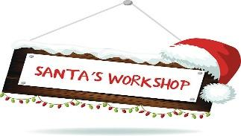Santa’s Workshop: Santa's Workshop is coming in December. We are looking for volunteers to join the planning committee, make handmade items, wrapping and/or set-up, and day of help. If interested please return the signup form by November 20th. Any questions please email Ashley DiGiorgio at santasworkshop2019@yahoo.com

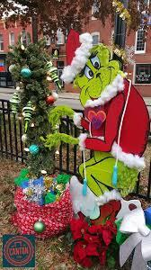
Lamppost: Saint Casimir has the opportunity to participate in the Christmas lamppost contest in O’Donnell Square. We welcome volunteers to join the decorating committee. Email Alissa Manna if interested at amanna@stcasimirschool.us.

Ms. Shirley’s celebration: We will celebrate the life of Ms. Shirley at the 8:15 Mass on Friday. All are welcome.
Shakespeare off the Page: Our middle school students will participate in an interactive workshop on Shakespeare’s’ work on Friday.
Soccer Shots, Winter sessions indoor Jan 14- Mar 3rd 8 week sessions
Pre-k 3 and 4
Wednesdays at 12:30
https://ssbaltimore.configio.com/pd/584/st-casimir-catholic-school-winter-2020-classic
New******
Soccer shots for K, Grades 1 and 2
Wednesdays at 3:15
https://ssbaltimore.configio.com/pd/586/st-casimir-catholic-school-winter-2020-premier
A look ahead:
Friday, 11/ 15: Audubon trip (weather permitting) – pre-k 4
Wednesday, 11/ 20: Reginald Lewis Museum – middle school
Tuesday, 11/ 26: Museum of Industry trip –intermediate
Tuesday, 11/ 26: Pre-k 4 Thanksgiving prayer service
Wednesday, 11/27: Noon dismissal after care ends at 4 p.m.

