ENTERING PRE -K 4
Summer fun
Here is the workbook for Pre-K 4 Summer work.
Focus on the following skill pages:
Pages: 24-52, 46-55, 65-75.

Pre-K Workbook
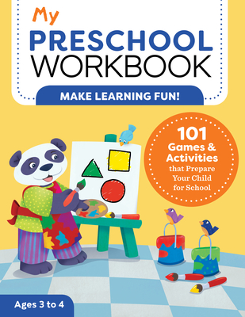

Pre-k 4 Booklist 2022-23
1. The Very Hungry Caterpillar by Eric Carle

2. 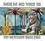Where the Wild Things Are by Maurice Sendak

3. 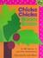Chicka Chicka Boom Boom by Bill Martin Jr.

4. 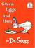Green Eggs and Ham by Dr. Seuss

5. 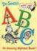Dr. Seuss's ABC: An Amazing Alphabet Book! by Dr. Seuss

6. 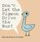Don't Let the Pigeon Drive the Bus! by Mo Willems

7. 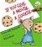If You Give a Mouse a Cookie by Laura Joffe Numeroff

8. 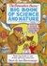The Berenstain Bears' Big Book of Science and Nature by Stan Berenstain

9. 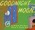Goodnight Moon by Margaret Wise Brown

10. The Cat in the Hat by Dr. Seuss

11. 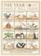The Year At Maple Hill Farm by Alice Provensen

12. 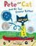Pete the Cat and His Four Groovy Buttons by Eric Litwin

13. 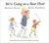We're Going on a Bear Hunt by Michael Rosen

14. 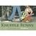Knuffle Bunny: A Cautionary Tale by Mo Willems

15. 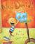No, David! by David Shannon

16. 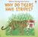Why Do Tigers Have Stripes? by Mike Unwin

17. 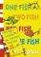One Fish, Two Fish, Red Fish, Blue Fish by Dr. Seuss

18. 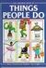Things People Do by Anne Civardi

