SAINT CASIMIR WEEKLY UPDATE

November 17, 2020

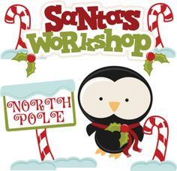Home School Association Meeting: Thank you to all who were able to join the Home School Association meeting tonight. Room parents will be getting more information to pass on to your class in the next few days concerning Santa’s Workshop. Thanks to Stacey Aisquith for running the meeting.
Virtue of the month: The virtue of the month for November is Manners. Awards for students of the month exhibiting this virtue consistently in each class will be given next Wednesday.
Grades close on Wednesday, November 25th. Conferences and report cards go home the week of December 7th.
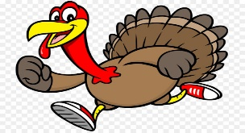Turkey trot: Tuesday, November 24th is School spirit dress down day in Thanksgiving colors and accessories. Keep those donations coming in. Kindergarten (Mrs. Mel) and Pre-K 4 are in the lead.
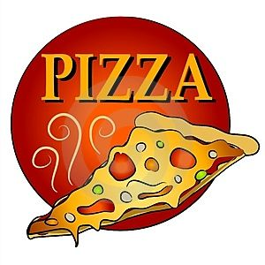Pizza Fridays: Website is up for December pizza orders.
Amazon Smile: This is a busy time for shopping.
Shop at AmazonSmile and select St. Casimir Church Baltimore as your charitable organization - Amazon will donate directly to St. Casimir School!
- Amazon donates 0.5% of the price of your eligible AmazonSmile purchases to the charitable organization of your choice – select St. Casimir!
- AmazonSmile is the same Amazon you know. Same products, prices and service.
Mass: There will be a school Mass on Friday, November 20th for Grades 2-8 followed by the student council induction.
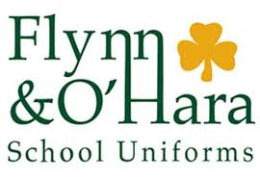Uniforms: Either the gym uniform or regular winter uniform needs to be worn each day after Thanksgiving break.
Wednesday, November 25th will be a noon dismissal with no after care.
