SAINT CASIMIR WEEKLY UPDATE
FEBRUARY 9, 2021
Attached:
- Valentine flyer
- Lenten food information

100 Days; Congratulations to all our teachers, staff, students, and families for completing 100 days of school during this most difficult year.

Super Bowl Squares: The lucky winners of the Super Bowl Squares are:
Grid 1: Dev Desai
Grid 2: Big Grump
Grid 3: Nick Ruocco
Grid 4: Will Teasle
Thanks to all who participated.

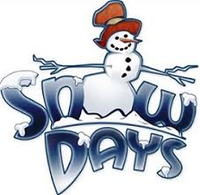Snow days: If we have additional snow days, they will become virtual learning days. We will begin a new class schedule beginning Tuesday, February 16th. Teachers will share details with you this week.

Middle School Midterms: Exams for Grades 6, 7, and 8 will take place the week of Feb 16- 20. Study guides will be sent home.
- Tuesday- LA
- Wednesday- Math
- Thursday- Science
- Friday- Social studies
Valentine’s Day: Valentine’s Day will be celebrated in school on Thursday, February 11th due to the long holiday weekend.
Lenten foods: Please consider volunteering to help with the Lenten food project. It is the largest fundraiser we have and helps us to meet our budget each year. The sign-up genius link is:
https://www.signupgenius.com/go/20f0f4ea9ac29a1f94-lenten

Attached is an order form for those who may be interested in ordering.

No School Friday, Feb 12 and Monday, Feb 15th,

