SAINT CASIMIR WEEKLY UPDATE
May 11, 2021

Thank you all so much for making Teacher Appreciation Week so special this year. The morning breakfasts, lunch, cards, gifts, and your generous bonuses are so very much appreciated by all of us. It is a year like no other and we thank you all for working so hard with us to make school a safe and happy place to learn whether at home or at school.

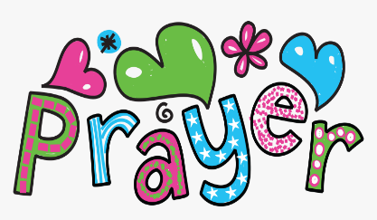Prayers: Please keep Mrs. Pintet and Ms. Bekky and their families in your prayers on the loss of their parents.
Virtual high school fairs: On Monday, May 24, 2021, and Tuesday, June 22, 2021, the Department of Catholic schools will be hosting virtual high school fairs for families interested in getting a jump-start on the high school admissions process. From 5:00 – 7:00 p.m., families will have the opportunity to engage representatives from Catholic high schools in the Archdiocese of Baltimore. The sessions will provide a glimpse into the admissions process, highlight signature programs, and share information regarding scholarships, financial aid, transportation, and much more! Please visit: https://www.archbalt.org/schools/our-schools/high-school-admissions/virtual-admissions/ to register.
Upon registration, Zoom log-ins for the participating high schools will be provided, and families may select up to three schools to visit the evening of the fair. Additional virtual fairs will be held this fall on September 29, October 11, and November 2. With each fair following the same format, we suggest families plan on attending one of the virtual fairs.

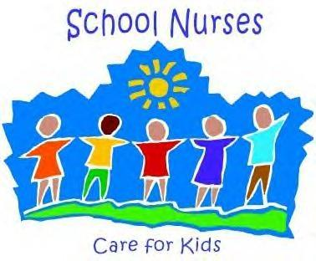Nurses Day: Tomorrow we will celebrate Nurses Day. Ms. Bekky was vital to keeping us all healthy and safe this year and we are happy to say she will be returning next year.

A Look ahead:
Wednesday, May 12th: Grade 8 retreat, lunch, and dismissal at 1.
May 24th and 25th; 8th exams
May 26th: Graduation family picnic
May 26th: Field Day- Pre-K 3, Pre-k 4, and K
May 27th: Field Day- Grades 1-8 (unfortunately, this year we are not able to invite parents)- we will take lots of pictures.
May 28th and 31st: No school

