SUMMER READING FOR STUDENTS ENTERING GRADE FIVE
Students entering grade five will be required to read TWO books this summer. The first is a novel that should be chosen from the list below. The second should be a nonfiction selection of their choosing. It is highly recommended that your child spend 15 min. a day reading throughout the summer.

REQUIRED FICTION NOVELS:
Students should choose to read one of the titles listed below. Each student should draw a Comic Strip including at least 5 boxes that include the beginning, 3 middle events, and the ending of the story. Please include a description of the event and some talk bubbles.

NOVELS (Choose One)
Matilda, by Roald Dahl
Coraline, by Neil Gaiman
Mudshark, by Gary Paulsen
The War with Grampa, Robert Kimmel Smith
The One and Only Ivan, by Katherine Applegate
Cricket in Times Square, by George Selden
Where the Mountain Meets the Moon, by Grace Lin
Escape from Mr. Lemoncello’s Library, by Chris Grabenstein
Chasing Vermeer, by Blue Balliett

NONFICTION BOOK:
Students must choose a nonfiction book on a high interest topic and complete the nonfiction book report (attached).

COMICSTRIP EXAMPLE: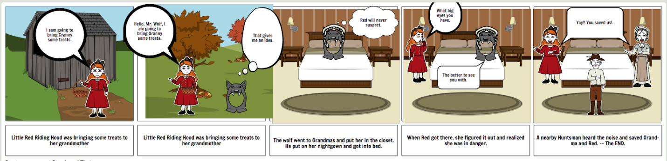

Summer Math
for Incoming Fifth Graders

This summer, students will earn their first two grades for math as fifth graders.

Summer math REQUIRED WORK is a leveled math review book available in major retailers and on Amazon.com for $3.99. Students should complete every third page (multiples of 3 (pg, 3, pg 6, pg. 9, pg 12, pg. 15, 18, etc.) This should be handed in the first week of school.

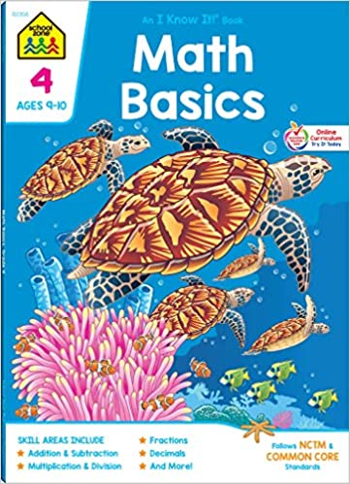

ISBN #: 978-0887431401

OPTIONAL EXTRA CREDIT: Multiplication/Division Practice:

Students should also choose six weeks to practice multiplication and division facts. (15 min. per day, 4 days per week). Math fact practice logs are attached and should be handed in when school resumes in the fall. Fact practice can include a parent quizzing a child, an online program such as multiplication.com, hooda math or mathisfun.com or any other method that allows a student to review math facts.

Please have a parent or caregiver sign each practice log. Practice logs may be split up over weeks as long as the student has six weeks worth of practice accounted for.

