Dear Future Second Grader and Family,

I would like to take this time to welcome you and your child to (almost) Second Grade. I am very excited to get to know each of you come September.
I want to make sure that your child keeps his/her brain warm all summer so I put together a fun and educational summer packet. I have also listed some online resources below that can be utilized in conjunction with the work provided.
Attached to this letter you will find a calendar of math activities for July and August and a reading log. Complete an activity in the box, on the calendar each day. After completing each box your parent should write his/her initials in the box. Use the reading log to record completed books read throughout the summer.
The calendars and reading log will be collected on the first day of school. They will count as a grade for the first trimester. Thank you for all your cooperation, have a great summer and I will see you all in September!!

Sincerely,
Mrs. Manna

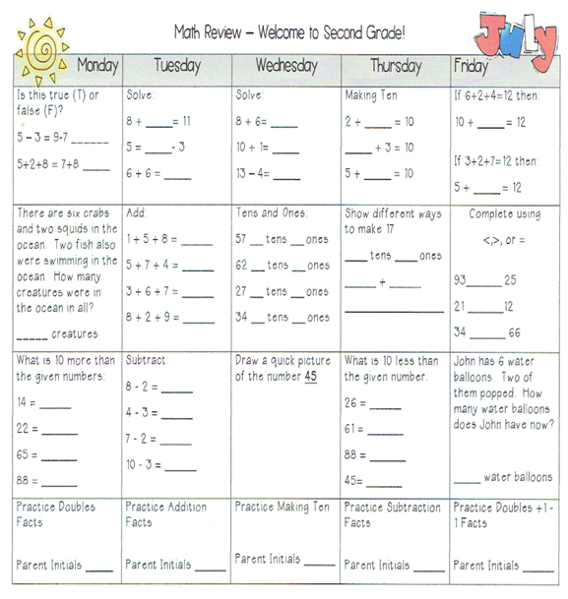
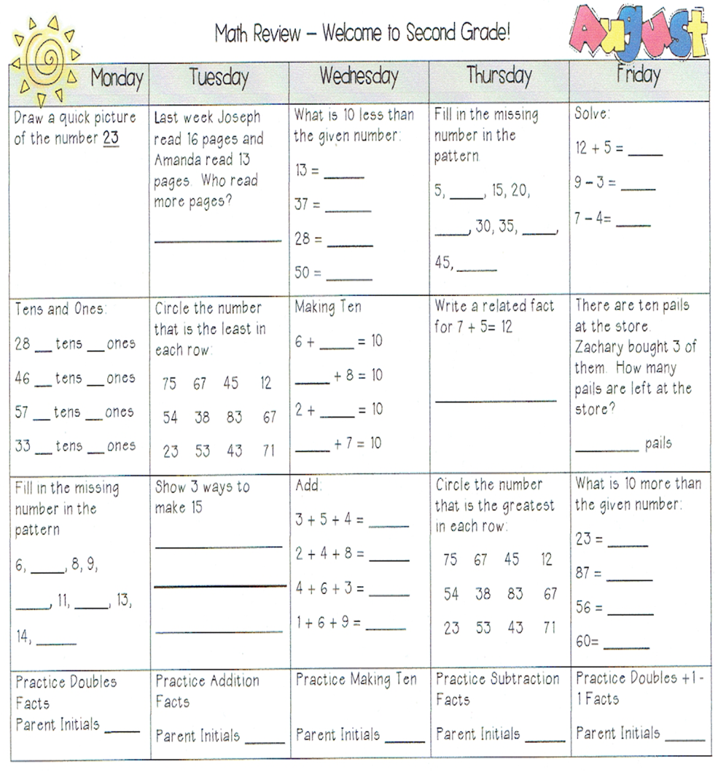
_______________________’s Summer Reading Log
Record completed books you have read throughout the summer.

Date | Book & Author | Stars  5=Best

Helpful Websites

Reading Comprehension Resources:
- www.education.com/activity/second-grade/reading
- www.teachervision.com/reading-comprehension/resource
- www.k5learning.com/reading-comprehension-worksheets/second-grade-2
Grammar Resources:
- www.education.com/worksheets/secondgrade-grade/grammar
- www.2ndgradeworksheets.net/freelanguageworksheets.htm
- www.jumpstart.com/parents/worksheets/grammar-worksheets
Recommended Books for 2nd Grade:
- www.goodreads.com/shelf/show/2nd-grade-reading-list
- www.sspl.org/children/booklists/grade2/

Math Resources:
- www.wildmath.com Select "Play the game". Select addition or subtraction and grade. You can race to beat
your time
- www.harcourtschool.com Click the red box, select math, select HSPMath, select Maryland, click on the ' l " ball or "2" ball for a challenge. Select a game. Addition Surprise, Addition Bricks, E-lab Number Patterns are very good.
- www.aplusmath.com go under "Flashcards" or "Game Room" on the left side of the screen. They can practice adding and subtracting.
- www.mathisfun.com Select Money then select Money Master, click on the US flag, select simple. Or you can select numbers then Math Trainer for adding and subtracting. Back at home screen select games and pick a game to play.
- www.illuminations.nctm.org Select activities then select grade level. Click on Search.
- www.funbrain.com Lots of fun games to choose from.

