September 17, 2019
To come home:
  - Saint Francis of Assisi Feast Day Luncheon form
  - Fall festival form
  - Calendar of H S A events
  - Blue Mass flyer
  - Ninja Math flyer (grade 3, 4, 5)
  - Spirit wear Store order form (electronically)
  - Boy scout information- to come home on Wednesday

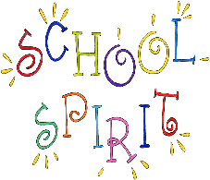Spirit Wear: Please note that Color Run t shirts are included in this order. This will be the only order for Color Run shirts. The Color Run for all grades will take place on Thursday, October 17th.
Soccer shots: Wednesday, September 18th will be the first day for Soccer Shots for Pre-k 3and 4. There will be two classes at 12;30 p.m. Half day students should bring their lunches. All students participating should have a water bottle with their name on it. Half day students can be picked up in the circle park at 1 p.m.
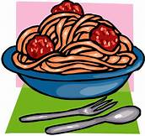Spaghetti dinner: On Friday the 20th the Home School Association will host their annual spaghetti dinner from 5:30- 7. Dinner will be served downstairs with activities for the children in the gym.
New Parents Social: All new families are invited to a social on Wednesday night for 5:30- 7 in the Kolbe Center hosted by the school and the ambassador families. The Home School Association will be available for any questions you may have, babysitting is provided for school children in the school.
Uniform Exchange: Used uniforms will be available for pick up next Thursday, September, 26th after school.
Lateness; It has been a great start to the year. Very few children have been arriving late for school. Thank you for all the effort that involves in the morning.

