July 2022
Dear families,
We are eager to have our returning and new families return to school. We are excited for the opportunity to learn with you and to celebrate all your accomplishments during this school year. We have worked hard and will continue to work diligently to provide a safe learning environment with the continued presence of COVID. With constant changes there may be changes to our plans. We will continue to update you as soon as any adjustments need to be made. It is important that all families follow any guidelines that are established.
Saint Casimir has achieved the highest growth in test scores in the archdiocese of Baltimore during the 2021-2022 school year. This is the second year in a row we have achieved this goal. Thank you to our teachers, staff, and students! Individual information will be shared with parents during parent conferences.
Our graduating 8th Grade scored higher on their Catholic high school entrance exams than the Archdiocesan average.
Due to increased enrollment, we have added an additional second grade this year.
Congratulations to Mrs. Rose on her retirement, We are working on plans to honor her many years at Saint Casimir.
Congratulations to Mr. Quinn and his family on the birth of their daughter Ile.
Congratulations to Mrs. Meghan Sitzler and her family on the birth of her twins, Lucy and Caroline.
Mrs. Alyssa Rodman will be teaching Pre- K 4 with Mrs. E. She joins us from the Baltimore County public schools.
Ms. Varen Lilley joins Ms. Wright in Pre-k 3 as an instructional assistant.
Mrs. Megan Zamzow will be joining Mrs. Shortall as the new first grade teacher.
Mrs. Manna is moving to second grade with Ms. Spence.
Ms. Cait Furlong will be our new third grade teacher joining us from Baltimore County public schools.
Mrs. Vicki Phillips is our new facilities manager.
Mr. Scott Sands will join the middle school team.
Used Uniform Exchange: Wednesday, August 10 from 5:00- 6:30

Information for the first days of school.
August 24: Cubby conferences - pre-k 4 only
Meet and Greet - playground Pre-K 4 5 -6 p.m.
August 25th :Cubby conferences pre-k 3 , K, Grade 1
Meet and Greet : Pre-k 3 playground - 5-6 p.m.
Supply drop off (Grades 2-8) 4:30-5:15(school)
Meet and Greet K- 8 Circle Park 5:15- 6:15 p.m.
August 26 Cubby conferences Pre-k 3, 4, K and 1

August 29 ^{th;} First day of school K-8
Pre-k 3 and 4 will get an email from your teacher explaining the first days.
Noon dismissal
August 30th
Noon dismissal
August 31st
Full day of school
September 1st
Full day of school
Back to School Night
Grades 2-3 -5:00
Grades 4 and 5- 5:45
Middle School 6:30
September 2nd
Noon dismissal

Morning Arrival: Please note being on time to school is very important.
Grades K -8 should enter by the front door between 7:40- 7:55. Children are marked late at 8:00.
Pre-k 3 and 4 should be dropped off at the back playground door between 8:00- 8:15 .
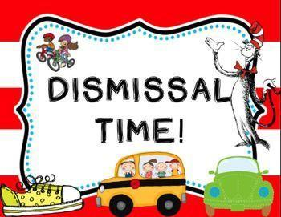Dismissal
Pre-k 3 and 4 will be dismissed at back door at 2:45
Kindergarten and first grade will be dismissed at 2:50 in front of church
Grades 2, 3, 4, 5 will be dismissed at 3:00 in front of church.
Middle school will be dismissed at 3:05
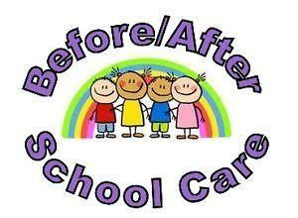
Before school care begins at 7:15 and has limited enrollment.
Before care begins on Tuesday, September 6th.
After care begins on Wednesday, August 31st.
Please do not hesitate to call the school office with any questions. Enjoy the remainder of the summer.

Sincerely,
Mrs. Heffner Principal

